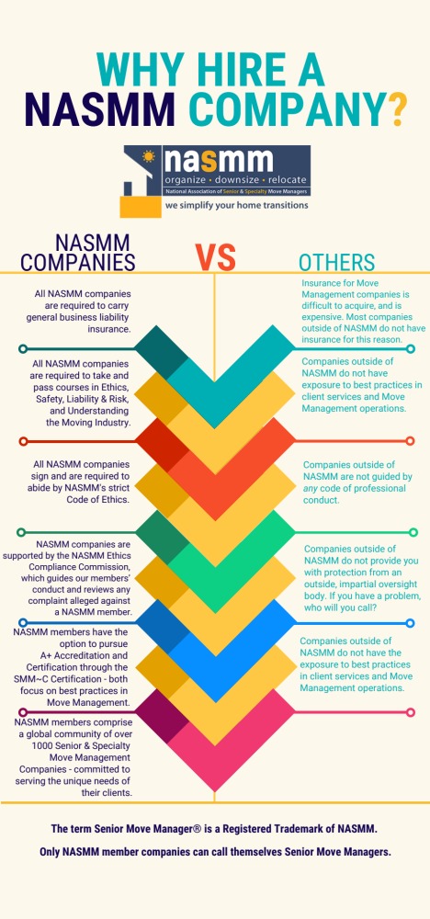
YOUR COMPANY NAME - PHONE - EMAIL

